Collections Assignment

1)Write an application that stores 10 unique products objects.in case there is an attempt to add a duplicate product it should be silently rejected.

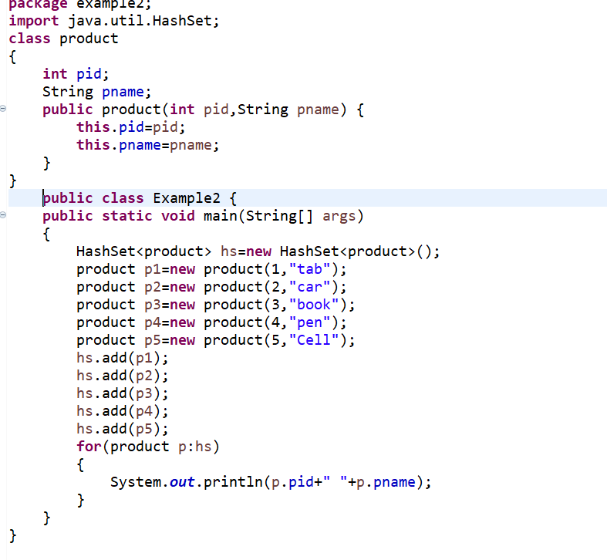

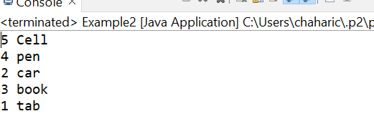

2)Given a linked list of objects representing date of birth. print the dates along with the message. your date of birth is dd-mm-yyyy, and it was or was not a leap year.

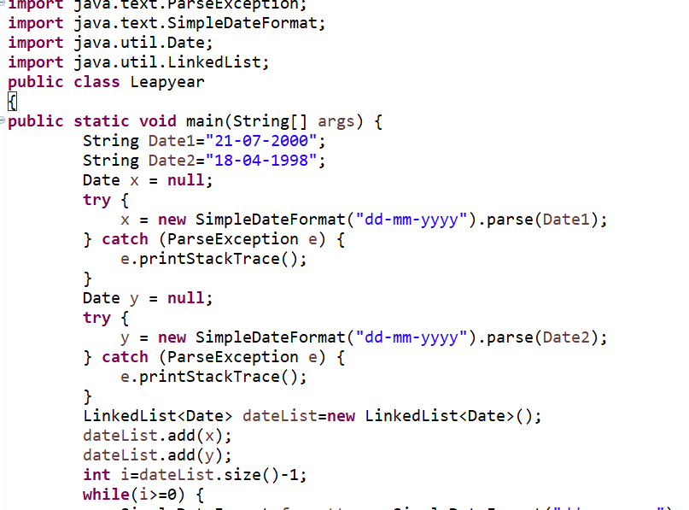

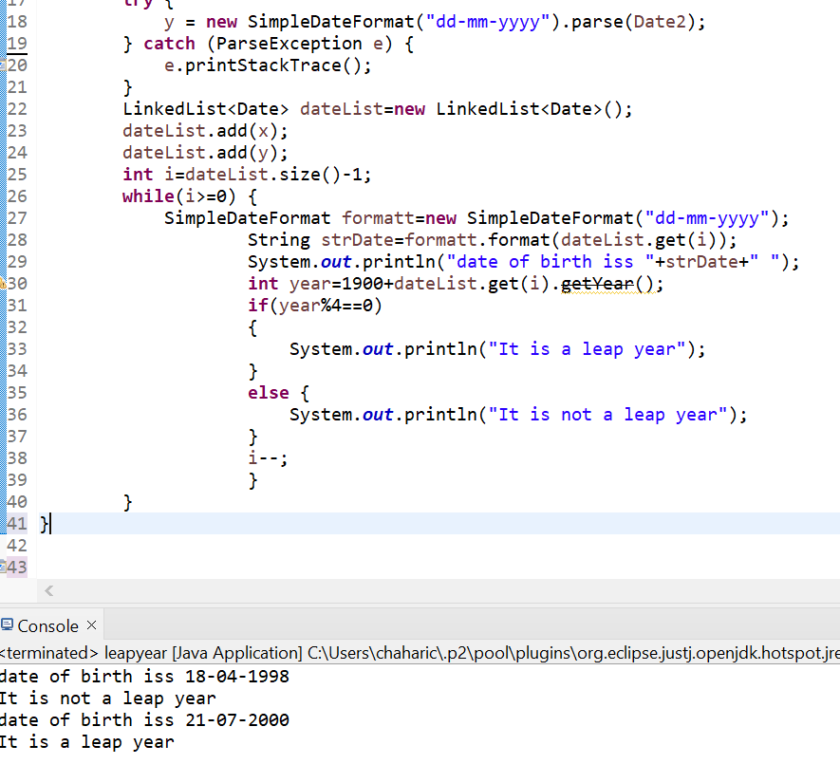

3)Given a tree map which has phone numbers for keys and contact objects for values.

a) Fetch all the keys and print them.

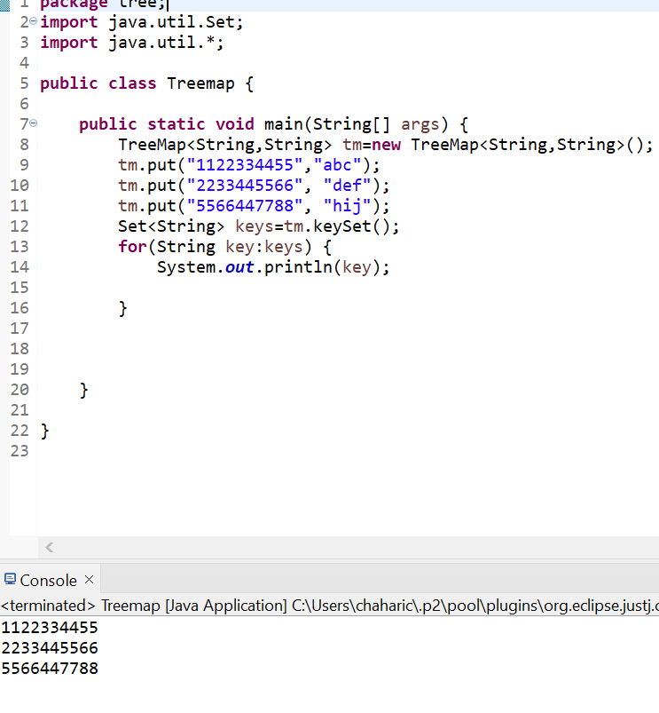

b) fetch all values and print them.

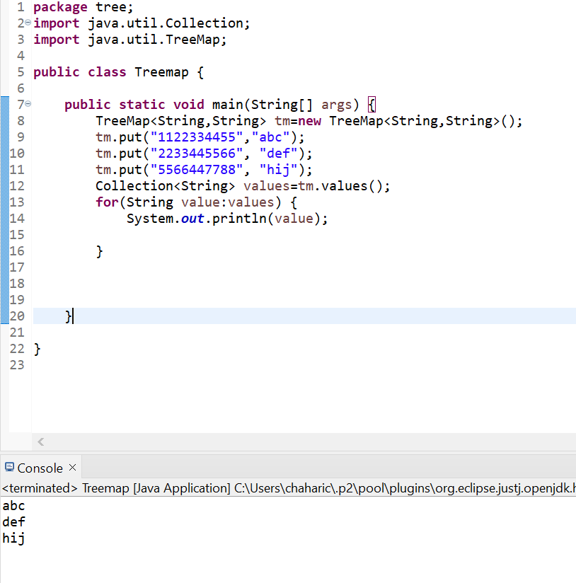

c)fetch all keys and values and print them.

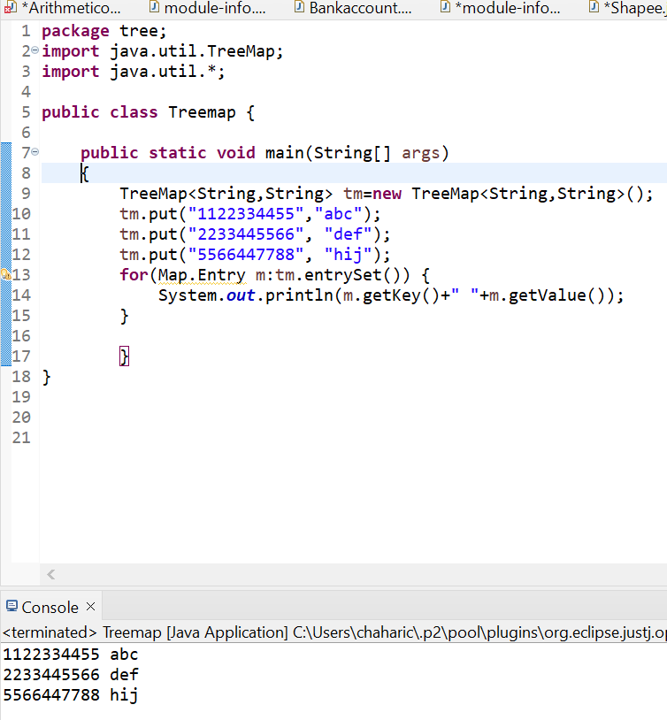

4) Store at least 10 Employee objects in an Tree Set<employee>. When the application runs the user should be asked to select one of the options upon which you will print the employee details in a sorted manner.

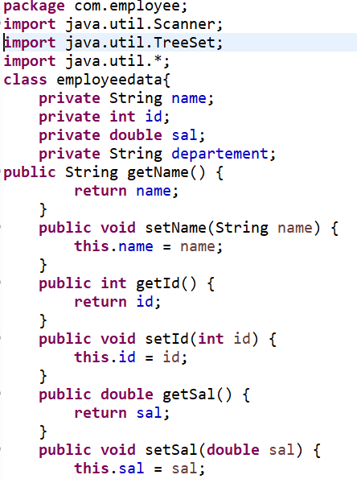

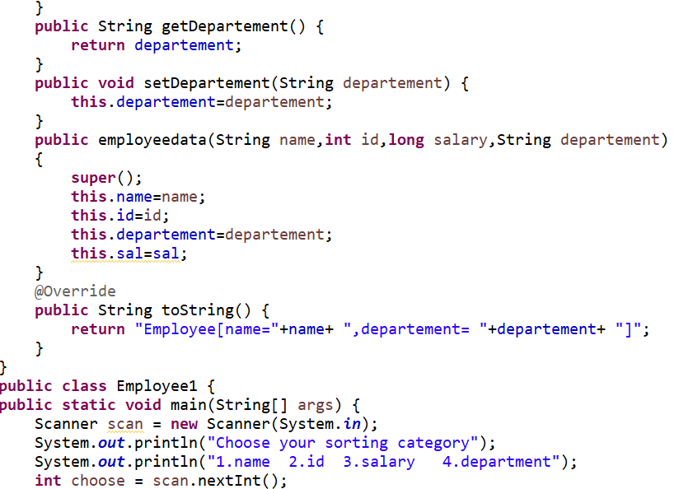

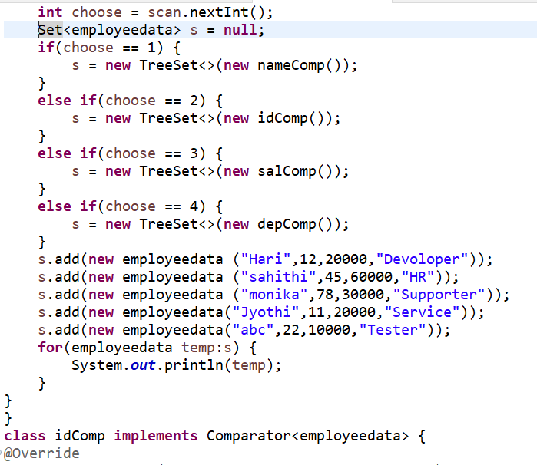

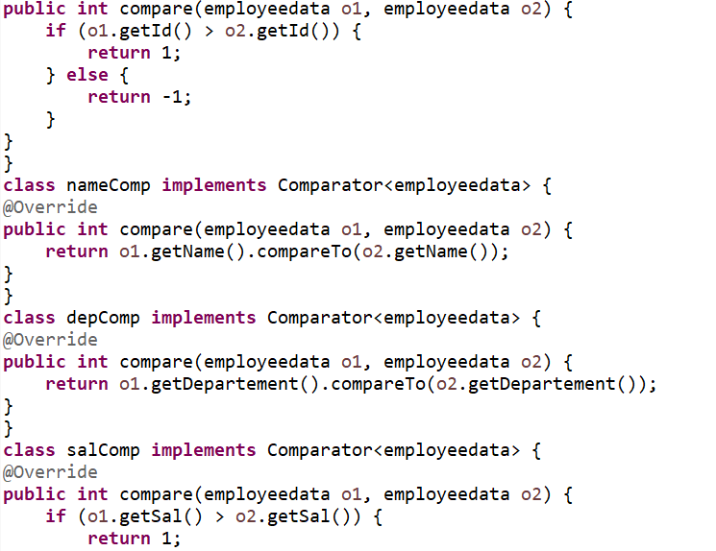

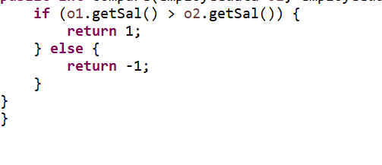

Output:

